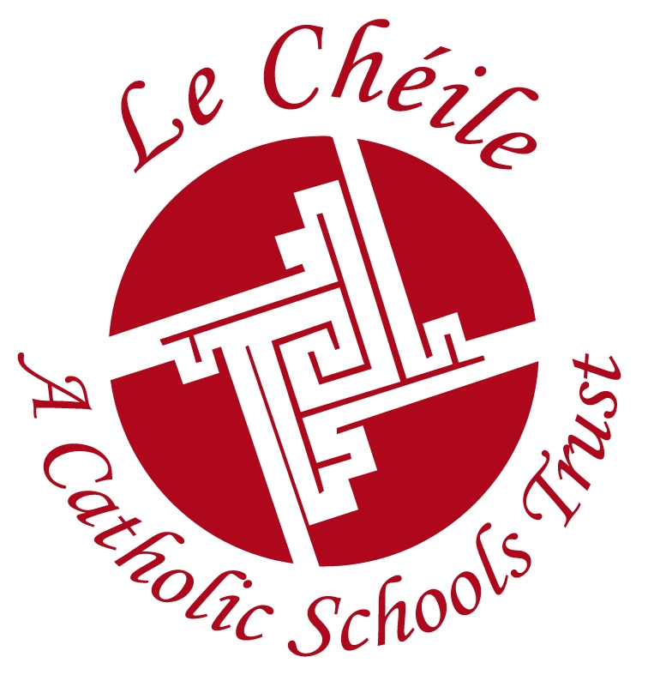

Ardscoil La Salle
_________________________________________________________
Raheny Road, Raheny, Dublin 5. Tel: 848 0055. Fax: 848 0082.
Website: www.ardscoillasalle.ie
Email:secretary@ardscoillasalle.ie
Twitter: @ardscoillasalle

APPENDIX 1 COVID-19 Policy Statement

Ardscoil La Salle is committed to providing a safe and healthy workplace for all our staff and a safe learning environment for all our students. To ensure that, we have developed and updated the following COVID-19 Response Plan. The BOM/ETB and all school staff are responsible for the implementation of this plan and a combined effort will help contain the spread of the virus. We will:

- continue to monitor our COVID-19 response and amend this plan in consultation with our staff
- provide up to date information to our staff and students on the Public Health advice issued by the HSE and Gov.ie
- display information on the signs and symptoms of COVID-19 and correct hand-washing techniques
- agree with staff, a worker representative who is easily identifiable to carry out the role outlined in this plan
- inform all staff and students of essential hygiene and respiratory etiquette and physical distancing requirements
- adapt the school to facilitate physical distancing as appropriate in line with the public health guidance and direction of the Department of Education
- keep a contact log to help with contact tracing
- ensure staff and students engage with the induction / familiarisation briefing provided by the Department of Education
- implement the agreed procedures to be followed in the event of someone showing symptoms of COVID-19 while at school
- provide instructions for staff and students to follow if they develop signs and symptoms of COVID-19 during school time
- implement cleaning in line with Department of Education advice

All school staff will be consulted on an ongoing basis and feedback is encouraged on any concerns, issues or suggestions.

This can be done through the Lead Worker Representative(s), who will be supported in line with the agreement between the Department and education partners.

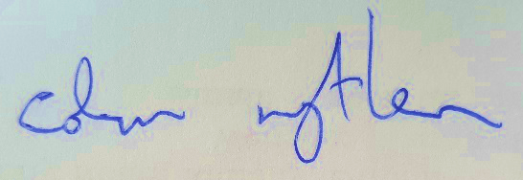
Signed: ____________________ Date: _24th August 2021____

